Report Preparation Guidelines

1. Basics
Report example presented at the end of this guide can be used as a template

Text painted green are comments

Report includes; Cover, Interior cover, Preamble, Sections and Appendix. Preamble contains, statement of authenticity, summaries and contents. Sections contain the report contents. Appendix contains additional info such as detailed design, important long code, proofs, etc.

2. Page Setup
Page size A4, top-bottom margins 2.5cm each, left margin 3.3cm and right margin 2.2cm.

Page numbers are placed on top right cornet of the page. Preamble page numbers should be roman numerals (e.g. I , VI , IX)

The rest of the report after preamble should use arabic numerals (e.g. 1, 2...).

3. Paragraphs

“Normal” paragraph style should be used. To clarify, this style contains, 12 pt, non-italic and non-bold “Times New Roman” font style.

First line of the paragraph should be aligned with the other lines and a signle line space should be used between lines.

Subsection header styles are given below

1. Birinci Başlık
1.1. İkinci Başlık
1.1.1. Üçüncü Başlık

4. Figures and Tables
Figure and chart captions should be below the figure and styled as follows.

Figure 1.3: A sample figure

Figure numbers should contain main section number such as Figure 1.3.

Table captions should be above the table and styled as follows

Table 1.6: A Sample table

All the figures and tables present in the report should be explained in the report text.

5. References
IEEE style numbered citation style should be used such as [23]. Each reference item should be cited at least once in the text.

İSTANBUL TECHNICAL UNIVERSITY
FACULTY OF COMPUTER AND INFORMATICS

Project Title
AI BASED TRADING BOT

Report Type
Graduation Project Report
Student Info
Oğuz Kopan
150130115

Department: Computer Engineering
Division: Computer Engineering

Advisor : Prof. Dr. Burak Berk Üstündağ

August 2023
ISTANBUL TECHNICAL UNIVERSITY
FACULTY OF COMPUTER AND INFORMATICS

Project Title
AI BASED TRADING BOT

Report Type
Graduation Project Report
Student Info
Oğuz Kopan
150130115

Department: Computer Engineering
Division: Computer Engineering

Advisor : Prof. Dr. Burak Berk Üstündağ

August 2023
Statement of Authenticity

I/we hereby declare that in this study

- all the content influenced from external references are cited clearly and in detail,
- and all the remaining sections, especially the theoretical studies and implemented software/hardware that constitute the fundamental essence of this study is originated by my/our individual authenticity.

İstanbul, date

Name(s) and Signature(s)

Oğuz Kopan

Project Title
AI BASED TRADING BOT

( SUMMARY )

English summary should be at least one full page and should not be longer than 2 pages,.

Summary should be styled with “normal” style.

The Financial Market is a complicated and ever-changing system. It is influenced by many factors that are uncertain. That's why it's hard to predict how stock prices will move. Machine Learning is a technology that helps computers learn and find patterns in big sets of data. We think that Machine Learning algorithms, with their ability to organize and learn by themselves, could be useful in predicting stock price changes and creating automated trading strategies based on those predictions. Some people have already used artificial intelligence techniques to predict market movements, but they usually don't test them in a real or simulated trading environment.

For my graduation project, I want to explore how different machine learning algorithms, can be used to predict how stocks in the S&P 500 will perform. Once we find the best algorithms, we will create automated trading strategies based on them. Finally, we will test these strategies in a simulated market trading environment to see if they actually work in predicting future performance.

In this project, I utilized various machine learning tools such as Facebook Prophet, LSTM, and the Predictive Error Compensating Wavelet Neural Network to make predictions. The core aim was to eliminate human emotions from trading decisions and allow machine learning to drive the process. The rationale behind this approach is that humans often make better decisions when they focus solely on data and charts without emotional biases.
To implement and test this idea, I deployed a trading bot specifically for Bitcoin due to its continuous 24/7 trading availability, which suits the project's goals. Access to foreign stocks, like those in the US, was limited in my location (Turkey), making Bitcoin a practical choice. Additionally, I leveraged the fee-free trading period on the Binance crypto exchange platform during deployment, leading to favorable performance results that showcased the predictive capabilities of machine learning models.
In the deployment phase, the trading bot executed hourly trades based on the AI predictions. While backtesting of the Predictive Error Compensating Wavelet Neural Network yielded impressive results, real-time performance with Bitcoin did not match expectations. To assess and compare the strategies, I developed a local website that displayed detailed graphical representations of backtesting and real trading results.

Project Title
AI BASED TRADING BOT

( ÖZET )

Turkish summary should be at least one full page and should not be longer than 2 pages,.

Summary should be styled with “normal” style.

Finansal Piyasa karmaşık ve sürekli değişen bir sistemdir. Belirsiz birçok faktörden etkilenir. Bu nedenle hisse senedi fiyatlarının nasıl hareket edeceğini tahmin etmek zordur. Makine Öğrenimi, büyük veri kümelerinde desenleri bulma ve öğrenme yeteneği sayesinde bilgisayarların öğrenmesine yardımcı olan bir teknolojidir. Makine Öğrenimi algoritmalarının kendi kendine öğrenme ve düzenleme yetenekleri nedeniyle, hisse senedi fiyatı değişikliklerini tahmin etmek ve bu tahminlere dayalı otomatik ticaret stratejileri oluşturmak için kullanılabileceğine inanıyoruz. Bazı insanlar yapay zeka tekniklerini piyasa hareketlerini tahmin etmek için kullanmış olsalar da, genellikle bunları gerçek veya simüle edilmiş bir ticaret ortamında test etmezler.
Mezuniyet projemde, S&P 500 endeksindeki hisselerin nasıl performans göstereceğini tahmin etmek için farklı makine öğrenimi algoritmalarının nasıl kullanılabileceğini araştırmak istiyorum. En iyi algoritmaları bulduğumuzda, bunlara dayalı otomatik ticaret stratejileri oluşturacağız. Son olarak, bu stratejileri gelecekteki performansı tahmin etmek için simüle edilmiş bir piyasa ticaret ortamında test edeceğiz.
Bu projede, Facebook Prophet, LSTM ve Hata Telafili Dalgacık Sinir Ağı (PECWNN) gibi çeşitli makine öğrenimi araçlarını tahminlerde kullanmak için kullandım. Temel amaç, ticaret kararlarından insan duygularını elemek ve süreci makine öğreniminin yönlendirmesine izin vermektir. Bu yaklaşımın arkasındaki mantık, insanların genellikle duygusal önyargılardan uzak sadece veri ve grafiklere odaklandıklarında daha iyi kararlar aldıklarıdır. Bu fikri uygulamak ve test etmek için, proje hedeflerine uygun olarak sürekli 7/24 ticaret yapabilen Bitcoin için özel bir ticaret botu geliştirdim. Konumum (Türkiye) gereği yabancı hisse senetlerine, örneğin ABD hisselerine erişim sınırlıydı, bu nedenle Bitcoin pratik bir seçenekti. Ayrıca, dağıtım sırasında Binance kripto borsası platformunda uygulanan ücretsiz ticaret döneminden yararlandım ve bu durum, makine öğrenimi modellerinin tahmin yeteneklerini sergileyen olumlu performans sonuçlarına yol açtı. Dağıtım aşamasında, ticaret botu AI tahminlerine dayalı olarak saatlik işlemler gerçekleştirdi. Hata Telafili Dalgacık Sinir Ağı'nın geri testi etkileyici sonuçlar verdi, ancak Bitcoin ile gerçek zamanlı performans beklenen sonuçlarla örtüşmedi. Stratejileri değerlendirmek ve karşılaştırmak için, geri test ve gerçek ticaret sonuçlarının ayrıntılı grafiksel temsillerini sunan yerel bir web sitesi geliştirdim.
Contents

Contents should contain up to the third subsection.

Section
First Subsection
Second Subsection
Third Subsection

Space between section title and page number should be filled with dots.

You shall use automatic content creation properties of the editır you use.

Contents 4
1 Introduction and Project Summary 5
1.1 Engineering Standards and Multiple Constraints 5
2 Comparative Literature Survey 6
3 Developed Approach and System Model 6
3.1 Data Model 6
3.2 Structural Model 6
3.3 Dynamic Model 6
4 Experimentation Environment and Experiment Design 7
5 Comparative Evaluation and Discussion 7
6 Conclusion and Future Work 7
7 References 7

Section Title

1 Introduction and Project Summary

Caution:Each section should start in a new page.

In the context of financial markets, human emotions often lead to suboptimal trading decisions. This project seeks to address this challenge by utilizing advanced machine learning methods to create an autonomous trading bot.

The project employs a multi-faceted methodology, encompassing various machine learning models. Notably, the project utilizes the Facebook Prophet model, LSTM networks, and introduces an innovative Predictive Error Compensating Wavelet Neural Network (PECWNN). These models are trained on historical cryptocurrency price data to predict future price movements, with PECWNN offering enhanced prediction accuracy by accounting for predictive errors.

Machine Learning presents a compelling avenue for understanding and harnessing patterns within vast datasets. By enabling computers to learn and adapt autonomously, ML algorithms hold the promise of predicting stock price fluctuations and subsequently devising automated trading strategies based on these predictions. While various attempts have been made to employ artificial intelligence techniques for market prediction, the real-world application of these algorithms remains largely untested within authentic or simulated trading environments.

The overarching objective of this graduation project is to explore the potential of diverse machine learning algorithms in predicting the performance of stocks listed within the S&P 500 index. This exploration extends to the creation of automated trading strategies rooted in the insights drawn from these algorithms. Ultimately, the effectiveness of these strategies will be evaluated through rigorous testing within a simulated market trading environment.

It is essential to underscore the significance of cumulative gains, particularly within the context of the stock market. The compounding effect of even modest daily gains can yield remarkable outcomes over extended periods. Consider, for instance, a seemingly minor daily gain of 1%. Over the span of a year, this unassuming increment can translate into a staggering 3778% return on investment, illuminating the potential of exponential growth fueled by consistent gains. This underscores the importance of adhering to enduring strategies that capitalize on the compounding effect, ultimately fostering substantial wealth creation. As this project unfolds, it underscores the dynamic interplay between cutting-edge technology, financial strategies, and the undeniable power of cumulative gains in shaping successful investment outcomes.

Here is a chart demonstrating the yearly cumulative gains for different daily percentages:

Daily Percentage | Yearly Cumulative Gain
2% | 137740%
1.5% | 22914%
1% | 3778%
0.5% | 110%
0.25% | 34%
0.1% | 12%

If you start out with $100 at the beginning of the year and you were able to increase what you have by 1% every single day, at the end of the year, you would have $3,778.34 = $100 * (1 + 1%) ^ 365. That is 37.78x what you had at the beginning of the year. Get that 1% every single day!

The significance of cumulative gains becomes even more apparent when considering the compounding effect of daily gains in the stock market. A seemingly modest daily gain of 1% can yield remarkable results when compounded over a year. The power of compounding enables investors to earn returns not just on their initial investment, but also on the accumulated gains from previous periods. Over time, the growth becomes exponential, and the impact becomes more pronounced. For instance, assuming a consistent 1% daily gain, an investor would realize an astonishing 3778% return on their investment over the course of a year. This exponential growth demonstrates the potential of cumulative gains in the stock market. By consistently achieving even modest daily gains, investors can achieve substantial results over extended periods, highlighting the importance of staying committed to long-term strategies and harnessing the compounding effect for maximum wealth creation.

My primary aspiration is to cultivate a consistent and gradual accumulation of incremental gains each day, achieved through the precision and discipline of an automated machine learning bot. By harnessing the power of technology and eliminating the potential for human emotional biases to interfere, I seek to create a harmonious synergy between data-driven decision-making and the pursuit of incremental growth.

1.1 Engineering Standards and Multiple Constraints

In my proejct, I created ML models, backtesting code, AI based trading bot and local website for testing multiple.

Regarding ML models I worked I have used 3 different ML aproach: PECNET, LSTM, Facebook Prophet for pretiction results. With these models I created price-prediction columns for each date like below:

Colums are consecutavely Date-Closing Price-Prediction
2023-03-13 00:00:00 | 150.470001 | 151.63878462654878
2023-03-14 00:00:00 | 152.589996 | 154.62815601620483
2023-03-15 00:00:00 | 152.990005 | 154.5321786546631
2023-03-16 00:00:00 | 155.850006 | 156.3603851549988
2023-03-17 00:00:00 | 155 | 158.570771405365

....

Regarding testing the prediction preformance I created a iterative backtest algorithm.

Then I am iteratively checking closing price of each day and next days predictions. According to predicition for next day I am selling or buying stock. I have used long-short in my backtesting to be able to see prediction performance better. Having a “long” position in a security means that you own the security. Investors maintain “long” security positions in the expectation that the stock will rise in value in the future. The opposite of a “long” position is a “short” position [4]. Because if we can know the direction is down for the next day we can make money on that prediction and it should reflect our balance. Basically after run the code I can see the output like below:

---------------------------------------------------------------------------
Testing Special Strategy on | APPL
---------------------------------------------------------------------------
***************************************************************************
2023-02-23 | Net Asset Value = 10000.0
2023-02-23 | Buying 66 for 149.39999
2023-02-23 | Current Position Value = 9860.4
***************************************************************************
2023-02-24 | Net Asset Value = 9822.46
***************************************************************************
2023-02-27 | Net Asset Value = 9902.32
***************************************************************************
2023-02-28 | Net Asset Value = 9868.66
2023-02-28 | Selling 66 for 147.41
2023-02-28 | Selling 66 for 147.41
2023-02-28 | Current Position Value = -9729.06
***************************************************************************
2023-03-01 | Net Asset Value = 10007.26
2023-03-01 | Buying 66 for 145.31
2023-03-01 | Buying 68 for 145.31
2023-03-01 | Current Position Value = 9881.08
***************************************************************************
2023-03-02 | Net Asset Value = 10048.06
***************************************************************************
2023-03-03 | Net Asset Value = 10396.22
2023-03-03 | Selling 68 for 151.03
2023-03-03 | Selling 68 for 151.03
2023-03-03 | Current Position Value = -10270.04
***************************************************************************
2023-03-06 | Net Asset Value = 10205.82
***************************************************************************
2023-03-07 | Net Asset Value = 10357.46
2023-03-07 | Buying 68 for 151.60001
2023-03-07 | Buying 68 for 151.60001
2023-03-07 | Current Position Value = 10308.8
***************************************************************************
2023-03-08 | Net Asset Value = 10443.82
2023-03-08 | Selling 68 for 152.86999
2023-03-08 | Selling 68 for 152.86999
2023-03-08 | Current Position Value = -10395.16
***************************************************************************
2023-03-09 | Net Asset Value = 10598.86
***************************************************************************
2023-03-10 | Net Asset Value = 10740.98
***************************************************************************
2023-03-13 | Net Asset Value = 10607.02
2023-03-13 | Buying 68 for 150.47
2023-03-13 | Buying 70 for 150.47
2023-03-13 | Current Position Value = 10532.9
***************************************************************************
2023-03-14 | Net Asset Value = 10755.42
2023-03-14 | Selling 70 for 152.59
2023-03-14 | Selling 70 for 152.59
2023-03-14 | Current Position Value = -10681.3
***************************************************************************
2023-03-15 | Net Asset Value = 10727.42
2023-03-15 | Buying 70 for 152.99
2023-03-15 | Buying 70 for 152.99
2023-03-15 | Current Position Value = 10709.3
***************************************************************************
2023-03-16 | Net Asset Value = 10927.62
***************************************************************************
2023-03-17 | Net Asset Value = 10868.12
***************************************************************************
2023-03-20 | Net Asset Value = 11036.12
***************************************************************************
2023-03-21 | Net Asset Value = 11167.72
2023-03-21 | Selling 70 for 159.28
2023-03-21 | Selling 70 for 159.28
2023-03-21 | Current Position Value = -11149.6
***************************************************************************
2023-03-22 | Net Asset Value = 11269.22
***************************************************************************
2023-03-23 | Net Asset Value = 11192.22
2023-03-23 | Buying 70 for 158.92999
2023-03-23 | Buying 70 for 158.92999
2023-03-23 | Current Position Value = 11125.1
.....
.....
***************************************************************************
2023-07-13 | Net Asset Value = 18978.65
2023-07-13 | Buying 100 for 190.53999
2023-07-13 | Buying 99 for 190.53999
2023-07-13 | Current Position Value = 18863.46
***************************************************************************
2023-07-14 | Net Asset Value = 18993.5
***************************************************************************
2023-07-17 | Net Asset Value = 19320.2
---------------------------------------------------------------------------
2023-07-18 | +++ CLOSING FINAL POSITION +++
2023-07-18 | closing position of 99 for 193.73
2023-07-18 | Current Balance: 19294.46
2023-07-18 | net performance (%) = 92.94
2023-07-18 | number of trades executed = 98
---------------------------------------------------------------------------
At the end we can see total balance for the last day. Net performance shows us how much our balance are changed. As you can, our starting investment was 10k but we made at the end 19.2k. So net performance is 92.94%. In the backtest code I record every transaction so that I can able to generate beautiful and understandable graphs from them like below:
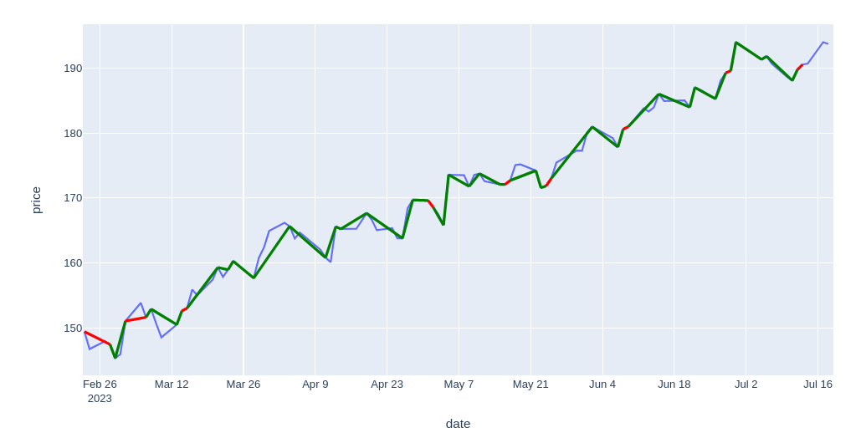
Blue line is the closing price for that stock. Green means our trade desicions made money for us. Green means we are on the wrong side for that period.

Below graph show us Closing Price vs. PNL(Balance):
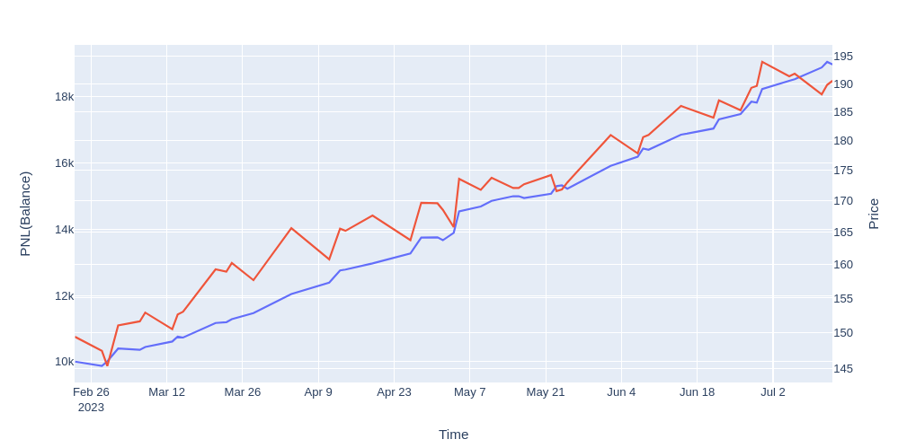

Then according to their backtest results I written backtest code that generates results over their predictions. If we had an investment according to their prediction result how much could we made? PECNET was the best. Thats why I implemented it in real time trading system with Binance(crypto exchange) api. I automated my trading bot in hourly bases on my local computer. I let it open from 2022-11-07 17:59 to 2023-01-01 19:59. And I have saved all the transactions in the csv. And save all the running code output in the log file.

Regarding my AI Based Trading bot, I implemented
My Trade history table:
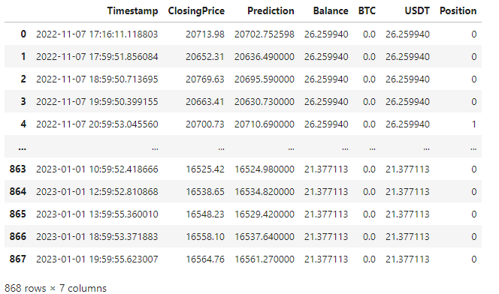

From this table I was able to generate good analysis with understandable Graphs.

This Graph shows prediction vs real price in hourly bases in my trading:
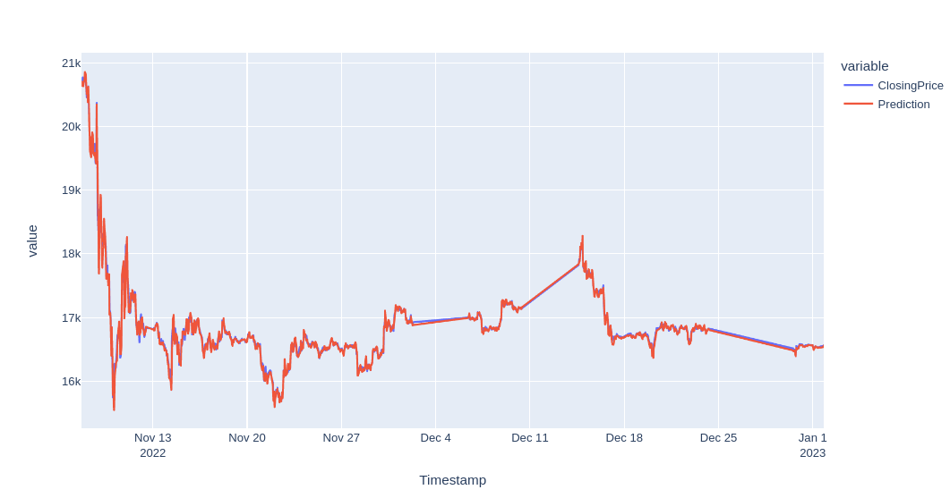
3 time this code somehow stopped thats why in the graph, you can see straight lines. Stop reasons was computer shutdown in some periods and regarding api is unreachablity.

There are some other graphs.

This graphs shows also when the application bought and when it sold Bitcoin in that timeline:
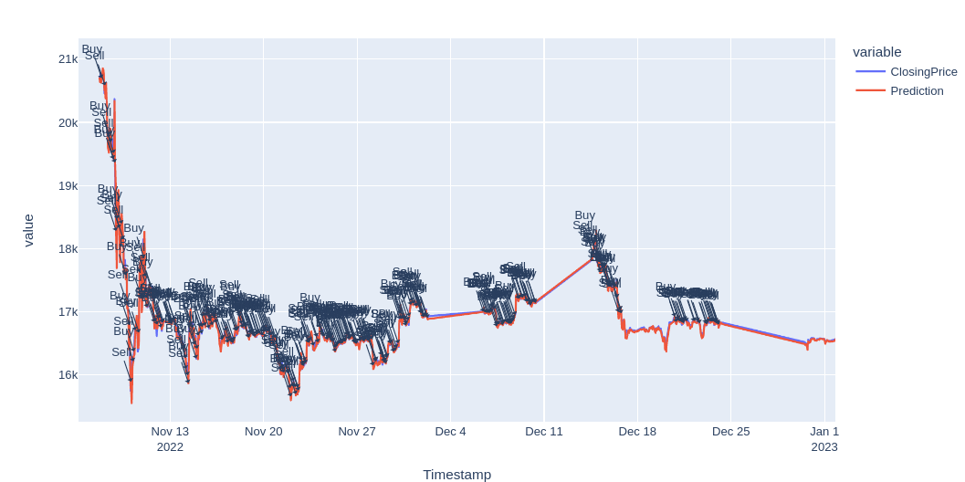
We can zoom in for some period to better see:
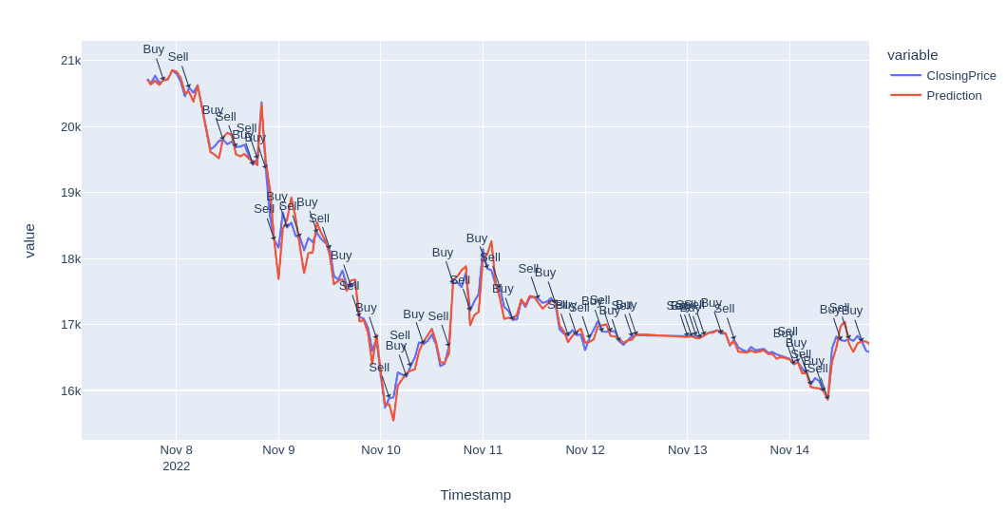

This graph shows our balance in the trading period:

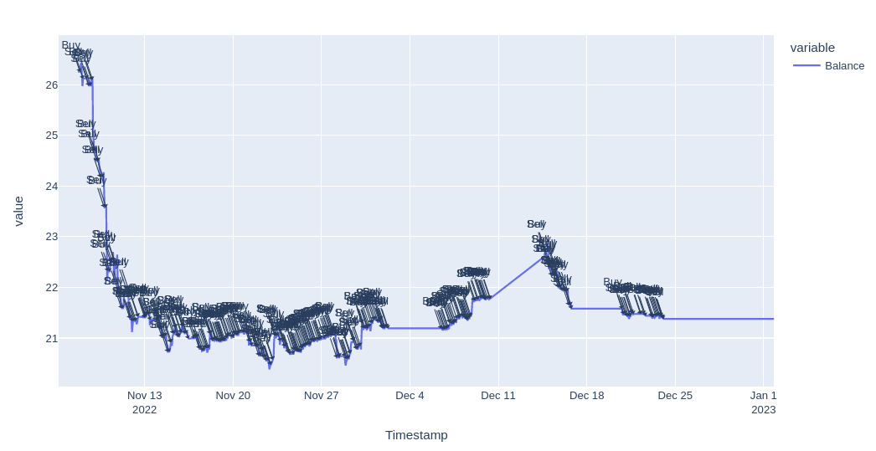
As you can see its very similar with Bitcoin price changes. When the bitcoin falls our balance is falling when it is going up it is also going up with the flow.

Compared to my backtest results, in the realtime results were so bad. In the backtest, when I was using test data for ML predictions, prediction price colums using future data most probably. Or I need to change the ML Network paramaters to be able to trade hourly in Bitcoin. Because when I backtested those results in daily manner and it was only on some good high Volume stock assests like Isbank from Turkey and Apple, Amazon, Google, AT&T and Ford Motor.
Section Title

2 Comparative Literature Survey
Warning: Each section should start in a new page.

Currently, for the time series analysis and the predictions, these models were popular: LSTM, Facebook Prophet. Additionally, I have used PECNET as my main ML model for the prediction for my trading bot. According to Ajla Kulaglic and Berk Ustundag PECNET provides significantly more accurate predictions. RMSPE error is reduced by more than 60% with respect to other compared ML methods [1].

Facebook Prophet is the other machine learning method I have implemented in my project. According to N. Suresh: Many models are currently in use Like Regression techniques, Long Short-Term Memory algorithm etc. FB Prophet is proven to perform better than most other Algorithms with better accuracy [2].

LSTM, Long short-term memory network is a recurrent neural network, aimed to deal with the vanishing gradient problem present in traditional RNNs. Its relative insensitivity to gap length is its advantage over other RNNs, hidden Markov models and other sequence learning methods. According to Ruobing Zhang, Long Short-Term Memory (LSTM) network models perform well in stock price prediction, and it is considered one of the
most precise prediction techniques, especially when it is applied to longer prediction ranges [3]. In my project I also tested this LSTM model with backtesting results over favorite stocks.

3 Developed Approach and System Model

Basically, my project consist of 3 main service. These are ML Models, Backtesting Service and Automated Trading system. You can refer below chart for general picture:
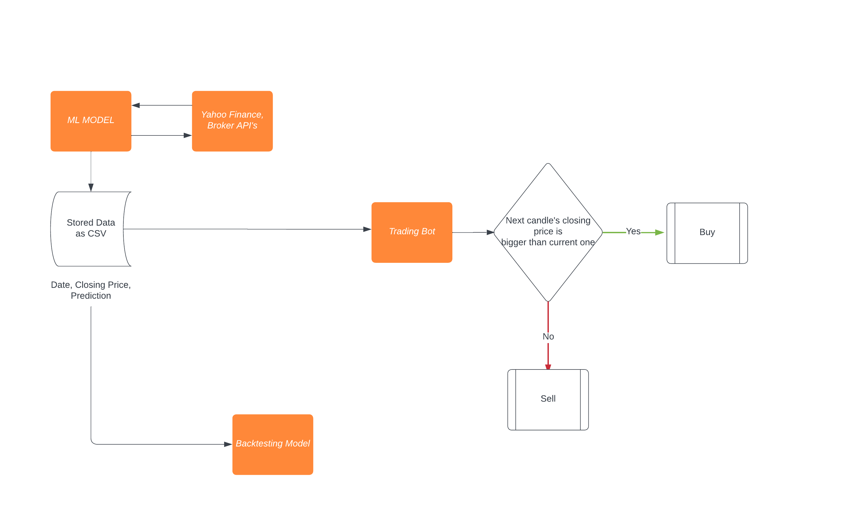
3.1 Data Model

My Data structure is like below. You can see that ML models give outputs for the date, price and predictions. In trading bot, we use these models for predicting next hour. When the trade happens we record trades in these columns: timestamp, closing price, prediction, balance, usdt, btc, position(bought or sold).

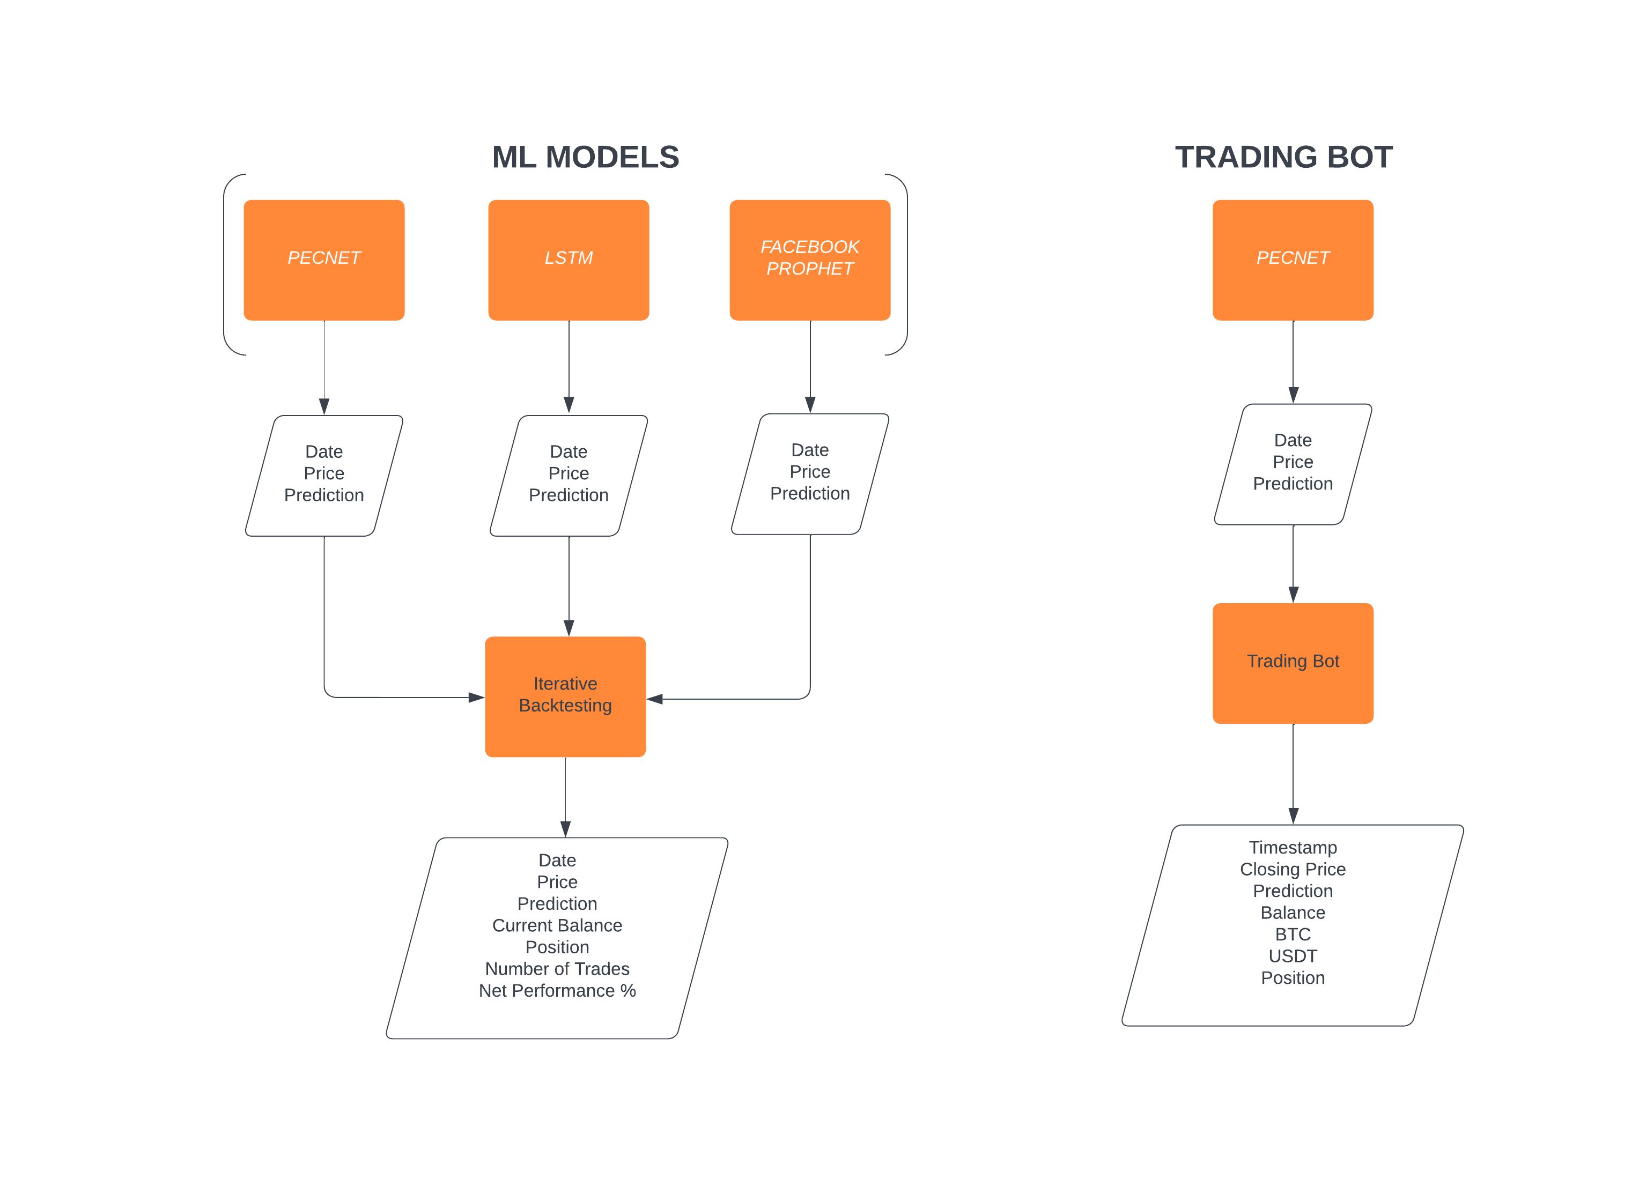
3.2 Structural Model

Below algorithms when I was doing backtesting worth to mention. In my iterative backtesting class I have below function to test my strategy:
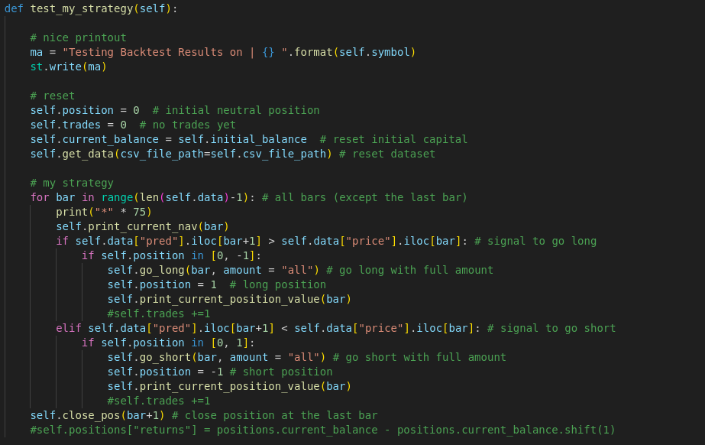

This is the long position logic:
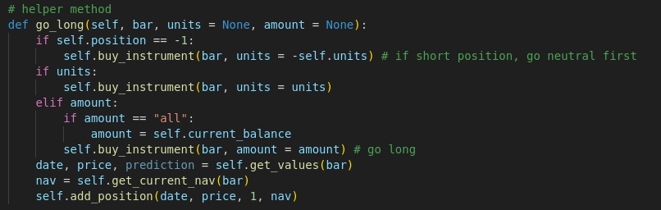
This is the short position logic:
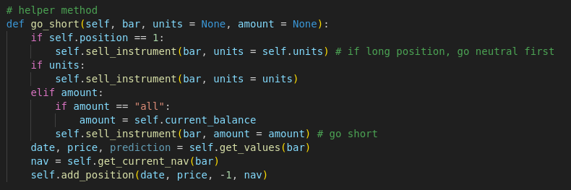

Below you can find class methods(sell_instrument(), buy_instrument()):

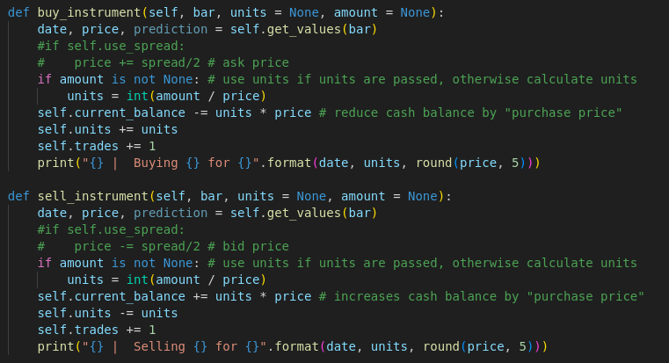
Of course there are a lot more methods but these are enough to mention to understand buying and selling logic.

Developed Approach:
My project actually florished on below PECNET(Predictive Error Compensated Wavelet Neural Network model) structure.
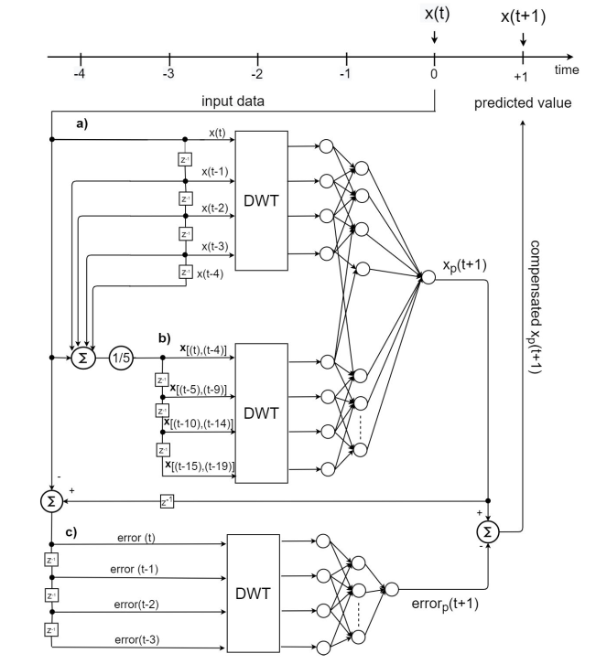
Figure 1. The Predictive Error Compensated Wavelet Neural Network model (PEC-WNN) Figure a) Consecutive input values shifted using the unit delay operator z −1 , b) Average values of size five computed applying the unit delay operator three times, c) Forecasting error calculation and input preparation for the compensation network [5].

The DWT is a linear signal processing technique that trans-forms a signal from the time domain to the "wavelet" domain [6].

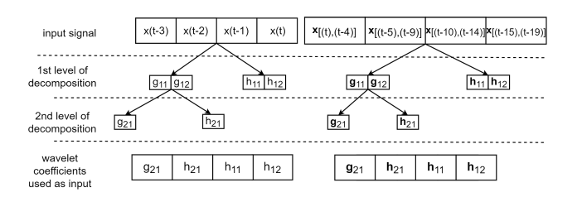
Figure 2. The DWT decomposition of the input signal using Mallat’s algorithm [6].

3.3 Dynamic Model

This section should contain dynamic models (both overall and component based) based on your system behaviour. UML seuquence diagrams, statecharts and state machines are some examples that you can use. You might also present the flow between your interface mockups.

Title: Prediction-based Trading - Sequence Diagram

Object: Trader
Object: PricePredictor
Object: Binance

Participant: Trader
Participant: PricePredictor
Participant: Binance

Trader->Binance: Request current price
Binance->Trader: Send current price

Note right of Trader: Perform prediction

Trader->PricePredictor: Request prediction for next hour price
PricePredictor->Trader: Send predicted price

Note right of Trader: Compare predicted price with current price

Note right of Trader: Make trading decision

Trader->Trader: Buy/Sell order (depending on prediction)

Note right of Trader: Execute buy/sell order

Trader->Binance: Place order on Binance
Binance->Trader: Confirmation of order placement

Note right of Trader: Update portfolio

Trader->Trader: Update portfolio

Note right of Trader: Continue monitoring and predicting

Trader->Binance: Request current price (for next iteration)
Binance->Trader: Send current price

Note right of Trader: Repeat the process

4 Experimentation Environment and Experiment Design

For my trading project, I simply did below steps:

- I used a regular computer with a Linux operating system.
- Linux cronjob ran my trading code every hour. It's like a schedule that helps me check my trading strategy regularly.
- I used Binance API(Crypto Exchange Platform) to get information about prices and make buying or selling decisions.
- My trading decisions are made from "Pecnet" prediction model. Simply, if it shows higher then the now for the next candle (hour), I bought otherwise I sold.
- Instead of using a complex database, I kept all my important information in simple CSV files.
- I wrote my trading code in a programming language called Python.
- To see how well my trading was going, I used a tool called Jupyter notebook. It helps me make colorful graphs to understand things better.
This special setup helped me try out different things and see how my trading strategy was doing. It's like a safe playground where I could test my ideas and make them better over time.

5 Comparative Evaluation and Discussion

This project was so complicated for some cases thats why for the sake of keeping everythink at the same place I have created local website with python streamlit:
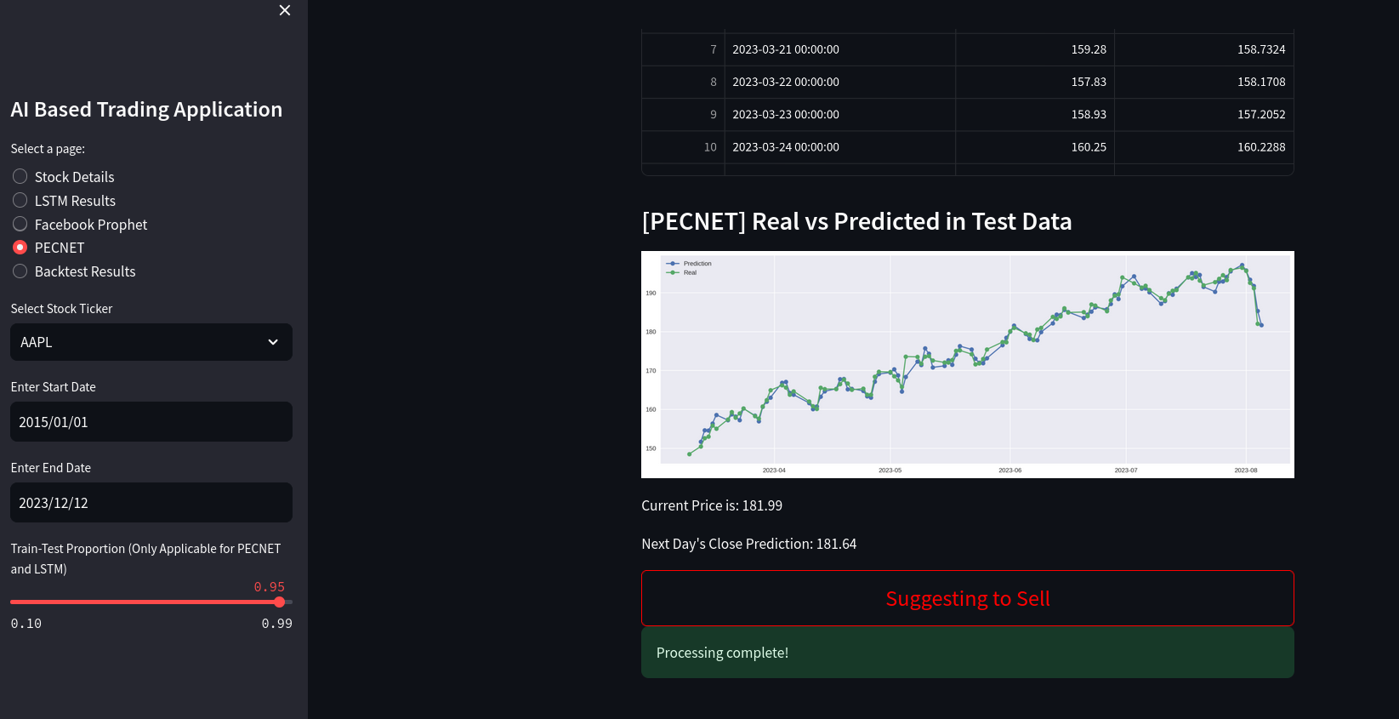
In this website you can see Stock Details, LSTM Predictions, FBProphet Predictions, PECNET predictions and Backtest Results in the tables and visual representations. From the left panel you can change timeline and select spesific stocks like Amazon, Google, Apple, Ford etc.. Also at the left panel you can change proportion of Test and Training data sets for the prediction results.

I have implemented itereative backtesting for all the ML model predictions. Acoording to their test prediction results I tested their performance according to thier PNL(profit). I made graph for where did I bougt whre did I sold the stock. And We can see how our balance are going.

This is example Performance (profit):
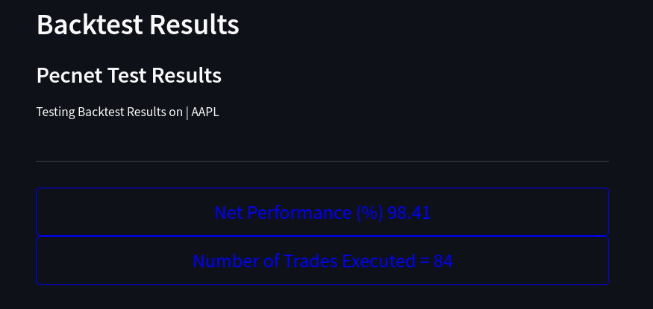

This is date, price, prediction table:
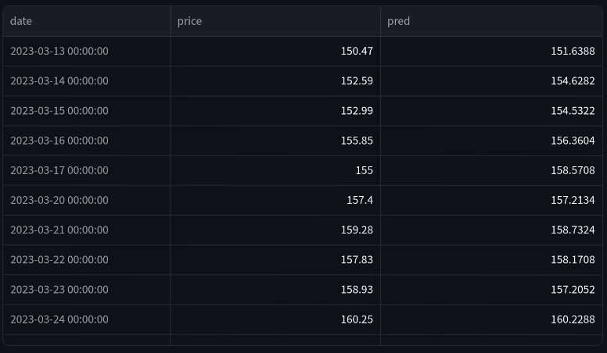
This table show us how the trades are made for the test set:
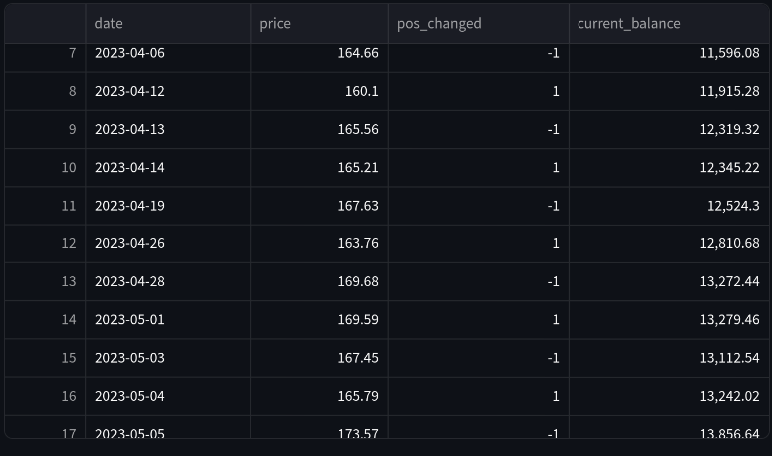
This is how our balance changed over time:

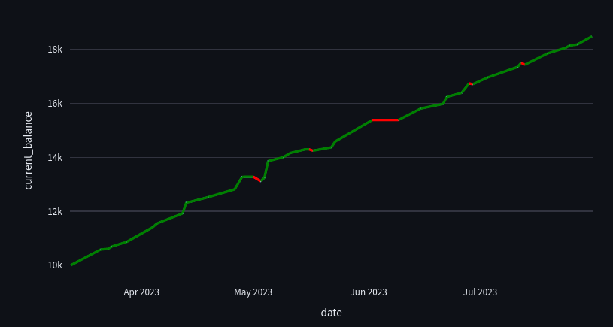

This graph show us how the balance vs price changed over time:
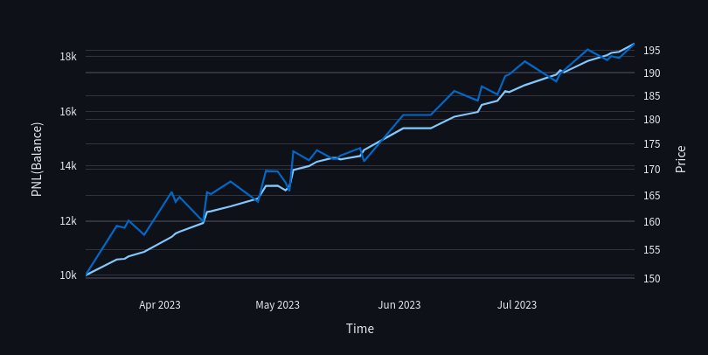
This graph shows how good our trade desicions over the price chart. Green means we are on the good desicion and we are earning money. Red means we are on the wrong side of themarket we are loosing money:

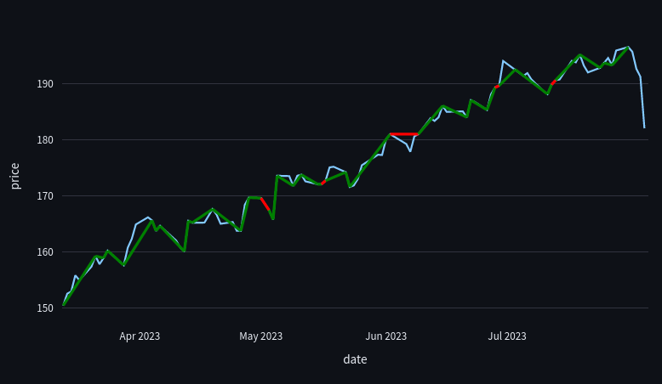

6 Conclusion and Future Work

While real-time trading presents challenges, the project demonstrates the potential of AI-driven trading strategies in mitigating human emotions and enhancing trading decisions. The lessons learned provide valuable insights for refining the approach. Future endeavors could explore ensemble techniques, sentiment analysis integration, and expansion to diverse markets for a comprehensive assessment of the AI trading bot's capabilities.
In summary, this project contributes to the evolving landscape of AI-driven trading and offers a platform for further research and exploration at the intersection of artificial intelligence and financial markets.

7 References

IEEE style references should be used as follows. Please pay attention that books, articles, proceedings and web sites have specific styles.

[1] Ajla Kulaglic and B. Berk Ustundag, “Predictive Error Compensating Wavelet Neural Network Model for Multivariable Time Series Prediction” TEM Journal. Volume 10, Issue 4, Pages 1955-1963, ISSN 2217-8309, DOI: 10.18421/TEM104-61, November 2021. [Online].Available: https://doi.org/10.18421/TEM104-61

[2] N. Suresh, “LSTM-based Stock Prediction Modeling and Analysis” South Asian Journal of Engineering and Technology, 123(2022) 152-157, DOI: 10.26524/sajet.2022.12.43
[Online]. Available: https://doi.org/10.26524/sajet.2022.12.43

[3] Ruobing Zhang, “LSTM-based Stock Prediction Modeling and Analysis” Atlantis Press, Advances in Economics, Business and Management Research, volume 211

[5] Ajla Kulaglic and B. Berk Ustundag, “High-Performance Time Series Prediction
With Predictive Error Compensated Wavelet Neural Networks” IEEE Access. Volume 8, Page:210534 [Online].Available: https://ieeexplore.ieee.org/document/9269330

[6] Ajla Kulaglic and B. Berk Ustundag, “High-Performance Time Series Prediction
With Predictive Error Compensated Wavelet Neural Networks” IEEE Access. Volume 8, Page:210533 [Online].Available: https://ieeexplore.ieee.org/document/9269330

[7] Ajla Kulaglic and B. Berk Ustundag, “High-Performance Time Series Prediction
With Predictive Error Compensated Wavelet Neural Networks” IEEE Access. Volume 8, Page:210534 [Online].Available: https://ieeexplore.ieee.org/document/9269330

